Introduction to ITWS

Quiz 2: April 19, 2018

Place your name on the top of this document in the header

Enter your answers directly into this document (with the exception of #1)

All answers should be in be in Your Own Words, and use proper grammar

Make sure your answers use an alternative font and/or color

Save this document as *yourname*-quiz2.docx

Place all documents including this one in a folder named

ITWSQuiz2-*yourname*-*yourRCSID*

When finished with the quiz, zip your folder and all related files into a file named

ITWSQuiz2-*yourname*-*yourRCSID*.zip

And submit it to LMS

1. Technology (coding): (40 points, 40 minutes)
   1. Given the Quiz2.html, .css, and .js files, make the following modifications; (40 points)

In the HTML;

* Change whatever is necessary to ensure the file(s) adhere to html5 syntax.
* Add your name in the h3 tags
* Change the title of the page to *yourname*-Quiz2
* Add a button at the bottom of the page with an id of “clickMe”
* When the ‘Save’ button is clicked – add the code necessary to POST a request to addText.php

In the JavaScript file:

* Add a function that will execute when the document is ready (You will need the jQuery ready function) and will
  + add a class of ‘blue’ to the <h3> tags
  + Show an alert that the page has loaded
  + When the button you added above is clicked – execute the jQuery fadeOut method on the paragraph text with a delay of 1500 ms.

In the CSS;

* Make any text in an element with a class of blue show in blue and in small caps.
* Make “Intro to IT – Quiz 2” and your name centered on the page

Your webpage (with the alert – which I moved for clarity) should look similar to the following;

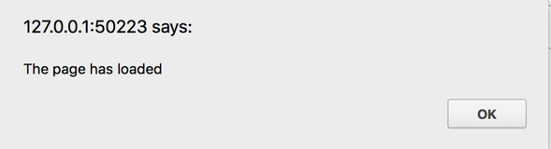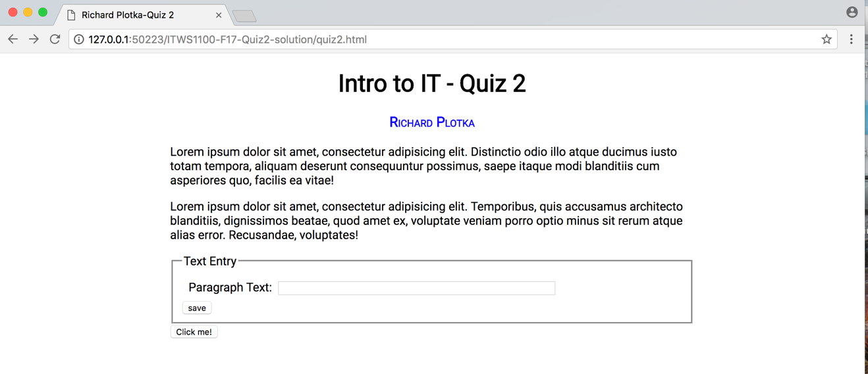

1. Technology (description) (20 points, 10 minutes): Web Development
   1. Explain the difference between IDs and Classes and Pseudoclasses? (2)  
        
      • The HTML id attribute specifies a unique id for a particular HTML element.  
        
      • HTML class attribute specifies one or more classnames for an element. The class attribute is mostly used to point to a class in a style sheet.   
        
      • A pseudo-class is used to define a special state of an element, and can be combined with CSS classes
   2. Explain the following code:   
      $("ol").filter(":has(li)").css("border", "5px solid blue"); (4)  
        
      This is a jQuery segment of code that selects all <ol> elements and filters them for those that have <li> elements within them. It then adds a CSS border with a 5px weight and color of solid blue.
   3. Write out the jQuery necessary to select all of the <li> tags with class “error” in a document’s div with a div id of ‘messages’. (4)  
        
      $(“div#messages:has(.error li)”);
   4. Given an index.php file with a form as in the AJAX example from class, explain the process that the web server goes through to process and send HTML to the browser on a GET request (5), on a POST (5)

A browser requests a web page from the web server and a full request-response cycle is initiated. By default, AJAX requests are sent using the GET HTTP method. The entire page is loaded via a GET request, and in doing so, requests are made for all other resources contained on the page. If there is a form on the webpage, then a POST request is made after the form’s “submission”. This takes the form data and reestablishes a connection to the web server where the information from the input field is processed and stored on the web server.

1. Git (30 points, 20 minutes)
2. What’s the difference between a “local version control system,” a “centralized version control system,” and a “distributed version control system?” (10 points)  
     
   • A Local Version Control System maintains a local database of the file version history on your hard drive   
     
   • A Centralized Version Control System maintains a centralized server with a database of file version history, and can be accessed from multiple computers  
     
   • A Distributed Version Control System maintains a server where the files are primarily stored, and other people can access it similar to a Centralized VCS, however the main difference is that people also maintain their own local versioning system. It’s especially helpful for quick and easy collaboration.
3. What kind of version control system is Git? (3 points)  
     
   Git is a Distributed Version Control System
4. What is SVN, and how does it differ from Git? (3 points)

SVN, or Subversion, is another version control system. It differs from Git in the sense that it instead uses a Centralized Version Control System.

1. What is a branch, and how is it used? (8 points)

Git branches are effectively a pointer to a snapshot of your changes. When you want to add a new feature or fix a bug, no matter how big or how small, you spawn a new branch to encapsulate your changes. This makes it harder for unstable code to get merged into the main code base

1. What is the “staging area” for git? (6 points)  
     
   The Git staging area is analogous to a cache of files that you want to commit. It allows you to prepare finished code for a commit while you work on other parts of the program. Staging allows you finer control over exactly *how* you want to approach version control.
2. “Predicting Consumer Tastes with Big Data at Gap” Case (10 points, 20 minutes)
   1. List the “three V’s” of big data and provide a definition for each as it relates to big data. (3 points)  
        
      The three V’s of Big Data are: volume, variety and velocity. Volume refers the physical quantities of data. Velocity is the measure of how fast the data is coming in. Variety is the diversity of the data, and ranges from photos to tweets, text messages to videos, sensor data, packets and much more.
   2. Which Gap Inc. brand is best served by the use of big data? Why? (7 points)  
        
      The Gap brand that is best served by the use of big data is most likely Banana Republic. This is because amongst both millennial and non millennial shoppers, Banana Republic consistently remains on one of the lowest rungs in terms of shopper brand consideration. Surely this has to do with BR’s more luxury focus, however using predictive modeling to assess consumer choices would help BR with sales, and by association, its brand image and choice amongst consumers.